Be True To Me, Clare, Be True to Me
April 19, 2017

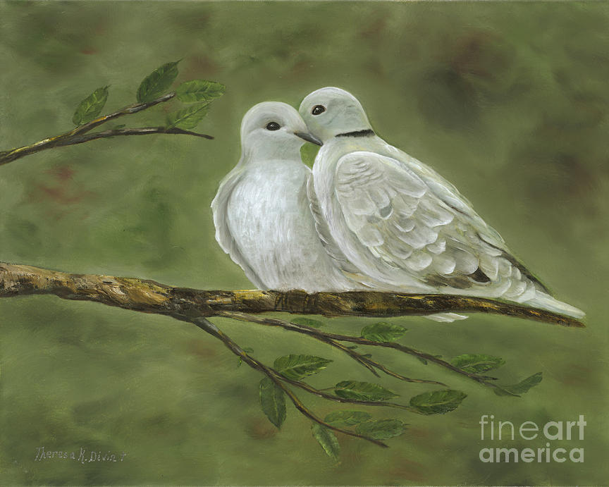
May the Lord grant us the discernment to scorn the gifts of the world and pursue His agenda for us as never before.

I have a very poignant and tender message that's important to share with you today. I began getting restless two days ago and getting a touch of spring fever. I was seeing everything bursting into bloom, and I got the itch to work in the garden. Well, I knew it wasn’t the Lord’s best for me, so I didn’t. But I managed to get a couple of things repotted. And I love miniature cactus gardens, so I took some cactus looking pretty lonely and made a tiny garden with rocks, etc. It reminded me very much of Phoenix where I raised my children for a few years.

At the time, I was shooting photo essays for the city of Phoenix, on their workers, and would take the kids on forays at night to the beautiful desert surrounding the city. It was a touch of nostalgia.

When I came into prayer the Lord began,

“Be My Dove, Clare. Be My pure dove, without compromise with your flesh, always anticipating what will please Me and what you can do for me. Even as you mentioned to your home team today. Anticipate what will please Me most and do that thing.

"Please do not give into your flesh - off on rabbit trails like primping plants. That’s the wrong direction, Beloved. You need to be more and more detached from these things so you can tend to My needs.

"The more you give in to distractions, the less I can use you. You must be faithful to carry this yoke I am preparing you for. You mustn’t let personal gain draw you away from your duty, to care for souls and make music.

"Ministry, ministry, ministry. Let that be your all-consuming occupation and leave by the wayside these childish preoccupations."

And here I want to add that I felt my angel nudging me. “You’ll never reach your goal in this life by allowing yourself to be distracted by useless things. In the end, it will disqualify you for the awesome plans God has for you.” That word from the Lord and that warning from my angel was enough of a warning for me to really put a check on myself. But I felt badly that I had compromised, and let the Lord down.

Jesus continued, “Oh, I have so much good for you to do but as long as you bow the knee to foolish things you are not ready, not fit, to carry the finest wine. You must be totally devoted to Me. Not half way, or a little corner for yourself. No - forsake yourself in all things and be about My business at ALL times. This will please Me and bring comfort to Me for those who are still chasing the world and all its benefits.
"To the degree that you water down your life with the little things, to that degree will you lose what have in store for you. So please, make a new dedication of purpose to Me and stick by it every day. I will send you little perks along the way, and you will delight in them because of My approval. But don’t look for them, Child."

He did do that, actually. While I was taking care of a piece of business for work here, I just stumbled onto purple shamrock plant seeds that were just beautiful. Just really make a beautiful plant. And I asked the Lord if I could have them. And low and behold, He said I could. I was shocked! So I was able to get the seeds and I'm going to plant them on the new moon. That was a little perk, that was a little something I wasn't expecting. Actually, when He said I could have it, I kinda cried. 'You're so good to me, Lord. You're so good to me! And yet You know how to hold me back from getting into things I shouldn't full throttle. Thank You so much, Lord.'

So, He gives us little perks, and they're not always in the physical world, mostly in the spiritual world. But this situation was a little different. He knows when it's time to bless us and when it's better for us to hold back things. And we really need to trust Him in that and pass by those things that we shouldn't even be looking at, really. You know how Amazon is! You go to get one thing and they've got your history, so they pull up a bunch of things that would be interesting to you. And that's a real exercise in self-control, let me tell you! You probably already know that.

Just like with Youtubes. All along the side they give you all these different topics. You go to check YOUR Youtube and they bring up all these different topics that are related. It's really, really a spirit of distraction just yanking at you to get over there. I've been learning, with His help, to be self-controlled and not look. Thanks be to God! I needed that grace.

And guys, when He pulls that grace, which He does sometimes - very often it's because of gossip or backbiting or having a thought of judgment against someone. When we begin to think that we are better than others... The Lord will pull His protection away and allow us to fall seriously. And for me, it's the panther. My panther is avarice. Thanks be to God, He really, really helps me with that. So, if there's hope for me - there's hope for you, too!

So, the Lord continued, "Look only for My needs every moment of the day and happy you shall be when I soon return to get you.

"You will not leave your songs unsung. They will go out across the land and the world. Only just limit yourself to My doings and let others function on that level if they want to. But you, be consecrated and alive to Me and dead to all else.

"Is that clear, Beloved?"

Yes, Lord. It is.

"I’m not trying to deprive you, rather I am preparing you for the greatest blessings your life can hold. Do Me the great honor of being faithful and ignoring the useless.

"I will protect you, but you must obey My promptings. If you scorn Me and go your own way, well... you will be taken captive by your enemies. Be true to Me, Beloved, as I know you can be. Be true to Me and we will scale this wall easily together and you will find yourself in a new and brilliant life which has been prepared for you."

And that's the end of His message.

And here, I want to add that there is nothing like feeling conviction that you have injured His heart with your indifference and self-will. Really, my heart was pierced when I understood how badly I had hurt Him.

Can you imagine this: you are waiting and waiting to find the right man to build your life with. Someone comes along who is totally in love with you and wants to build that life. But something in your spirit doesn’t set right, yet you ignore it because you are afraid you’ll never meet Mr. Right. And when you go ahead with that relationship, the Lord is so grieved and sad. If only you would have waited just a little longer, the man He had chosen for you is really perfect, and this man will disappoint you. If only you had followed My still small voice inside of you, you could have had everything you ever wanted in a man.

And that really happened to me, I married the wrong man the first time around, and the fallout is beyond comprehending from that decision. It's just huge.

The real issue here is unbelief and lack of trust. Me, with my human reasoning, thought I’d better take this proposal. But I felt in my heart it wasn’t right. I didn’t trust God enough to wait. I gave sin to my fears and unbelief. Now, this was before my conversion, before I really knew the Lord. But I remember how I felt - something wasn’t right and I didn’t listen to that voice.

It hurts Him so much when we don’t wait for His best for us. He knows what we will suffer because of our poor choices, and how much suffering it will cause for others. So, He tries to redirect us. But if we are proud, like I was, and still am, we don’t listen but go our own way. Oh, don’t let this happen to you, beloved Heartdwellers. Always wait on God’s best.

And I really sensed, when He said, "Be My pure Dove, Clare. Please, be My pure Dove. Don't run after your attachments." I could really feel it in my heart, that there was something lacking, that there was a purity there that I could have given Him but chose not to. That's a very pure thing. Pain, when you realize that He's looking to you for your purity and your faithfulness. And you're still being foolish

So, that's not to beat me. We have to go on from that point, knowing that the Lord loves us and He forgives. But let's not do that again! Which is what the impression leaves me with.

And I wanted to thank you so much, guys, for the donations that have been coming in. They've really helped us and we're in a much better place right now than we were. Thank you so very much for that. We appreciate it. Your faithfulness means a lot to us, 'cause it enables us to continue going and going and going.

So, the Lord bless you all and may He give us and impart to us the desire to be His pure Dove and not allow ourselves to be torn off in different directions from the flesh. God bless you.

